Credit Card Fraud Detection
Student Name : Ranganadh Kodali
Email: Ranganadhkodali@gmail.com
Contact: 00968 98568980 or 0091 6306517607
Objective:
The purpose of this project is to prepare ML/Dl model to classify the fraudulent transactions in credit card domain. As understand from the explanation, data set contain 99%+ genuine transactions and just 0.17% is only related to the fraudulent transactions. Which clearly indicating that data set imbalanced.
And another observation about input data is after performing PCA, which indicates that interpretation input features with the target variable is not possible.
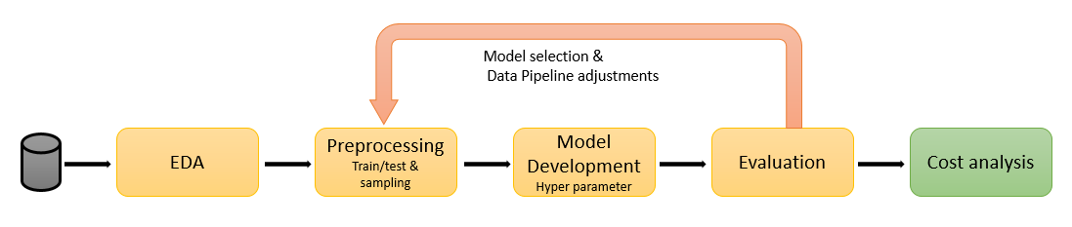
I am using above process in project development.
EDA: Since the data is already in the form of PCA, we will not expect to will have higher liberty to do in this area. However basic fundamental’s need to verified in this scope
- Verification of duplicates / missing values
- If any missing values deciding factors to treat this data
- Verify the scaling of each variable and see if we required to transform data to easy model development process.
- Visualize the data for univariate and bivariate analysis to see if data has any outliers
Preprocessing: we know that if data is imbalanced ML algorithms usually perform very poor. To address this we might need to try with different variations of under sampling / over sampling or systematic random sampling.. etc models and see the performance.
Model Development: based on the EDA, decide what kind of algorithms we can select such as linear models or nonlinear models. Try with the other model selection & feature selection API’s to select the high performance model.

Evaluation: since input data is imbalanced, we need to carefully come with the evaluation matrix to decide what kind combinations of metric’s need to be used to evaluate the model performance.
Cost analysis:
Based on the findings, calculate the cost analysis comparing the operation cost between cost saved through TP and loss raised through FN and how much savings our model contributed to the company.

